# Air Quality Prediction using Sample Dataset

# Step 1: Import Required Libraries

import pandas as pd

import numpy as np

import matplotlib.pyplot as plt

import seaborn as sns

from sklearn.model_selection import train_test_split

from sklearn.preprocessing import LabelEncoder, StandardScaler

from sklearn.ensemble import RandomForestClassifier

from xgboost import XGBClassifier

from sklearn.metrics import accuracy_score, classification_report, confusion_matrix

# Step 2: Load the Sample Dataset

df = pd.read_csv("/content/drive/MyDrive/Colab Notebooks/large_air_quality_dataset-1.csv")

# Step 3: Separate Features and Target

X = df.drop('Air_Quality_Level', axis=1)

y = df['Air_Quality_Level']

# Step 4: Encode Target Labels

le = LabelEncoder()

y_encoded = le.fit_transform(y)

# Step 5: Normalize the Features

scaler = StandardScaler()

X_scaled = scaler.fit_transform(X)

# Step 6: Train-Test Split

X_train, X_test, y_train, y_test = train_test_split(X_scaled, y_encoded, test_size=0.3, random_state=42)

# Step 7: Train Models

# Random Forest

rf_model = RandomForestClassifier(n_estimators=100, random_state=42)

rf_model.fit(X_train, y_train)

rf_pred = rf_model.predict(X_test)

# XGBoost

xgb_model = XGBClassifier(use_label_encoder=False, eval_metric='mlogloss')

xgb_model.fit(X_train, y_train)

xgb_pred = xgb_model.predict(X_test)

# Step 8: Evaluate Models

print("Random Forest Accuracy:", accuracy_score(y_test, rf_pred))

print("Random Forest Classification Report:\n", classification_report(y_test, rf_pred, target_names=le.classes_))

print("\nXGBoost Accuracy:", accuracy_score(y_test, xgb_pred))

print("XGBoost Classification Report:\n", classification_report(y_test, xgb_pred, target_names=le.classes_))

# Step 9: Visualize Confusion Matrix - Random Forest

plt.figure(figsize=(8, 6))

sns.heatmap(confusion_matrix(y_test, rf_pred), annot=True, fmt='d',

            xticklabels=le.classes_, yticklabels=le.classes_, cmap='Blues')

plt.title("Confusion Matrix - Random Forest")

plt.xlabel("Predicted")

plt.ylabel("Actual")

plt.show()

# Step 10: Visualize Feature Importance - Random Forest

importances = rf_model.feature_importances_

plt.figure(figsize=(10, 6))

sns.barplot(x=importances, y=X.columns)

plt.title("Feature Importance - Random Forest")

plt.xlabel("Importance")

plt.ylabel("Feature")

plt.tight_layout()

plt.show()

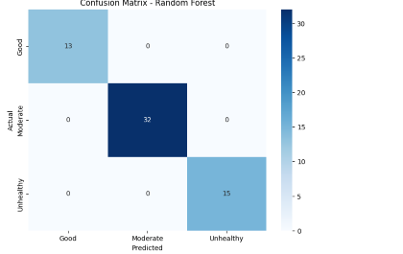

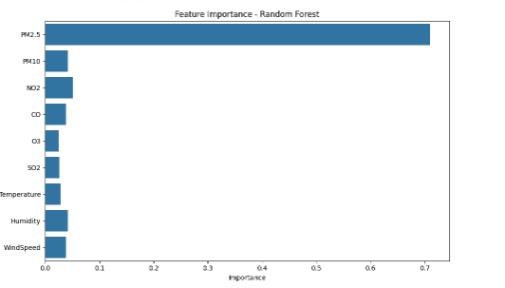

!pip install Gradio

# Air Quality Prediction and Gradio Deployment (All-in-One)

import pandas as pd

import numpy as np

import matplotlib.pyplot as plt

import seaborn as sns

import gradio as gr

import joblib

from sklearn.model_selection import train_test_split

from sklearn.preprocessing import LabelEncoder, StandardScaler

from sklearn.ensemble import RandomForestClassifier

from sklearn.metrics import accuracy_score, classification_report, confusion_matrix

# Step 1: Load the Dataset

df = pd.read_csv("/content/drive/MyDrive/Colab Notebooks/large_air_quality_dataset-1.csv")  # Ensure the CSV is in the same directory

# Step 2: Prepare Features and Target

X = df.drop('Air_Quality_Level', axis=1)

y = df['Air_Quality_Level']

# Step 3: Encode target labels

le = LabelEncoder()

y_encoded = le.fit_transform(y)

# Step 4: Normalize features

scaler = StandardScaler()

X_scaled = scaler.fit_transform(X)

# Step 5: Train-test split

X_train, X_test, y_train, y_test = train_test_split(X_scaled, y_encoded, test_size=0.3, random_state=42)

# Step 6: Train Random Forest Model

model = RandomForestClassifier(n_estimators=100, random_state=42)

model.fit(X_train, y_train)

y_pred = model.predict(X_test)

# Step 7: Evaluation

print("Accuracy:", accuracy_score(y_test, y_pred))

print("Classification Report:\n", classification_report(y_test, y_pred, target_names=le.classes_))

# Step 8: Save Model Artifacts

joblib.dump(model, "rf_model.pkl")

joblib.dump(scaler, "scaler.pkl")

joblib.dump(le, "label_encoder.pkl")

# Step 9: Gradio Interface for Deployment

def predict_air_quality(pm25, pm10, no2, co, o3, so2, temp, humidity, windspeed):

    model = joblib.load("rf_model.pkl")

    scaler = joblib.load("scaler.pkl")

    le = joblib.load("label_encoder.pkl")

    features = np.array([[pm25, pm10, no2, co, o3, so2, temp, humidity, windspeed]])

    scaled = scaler.transform(features)

    prediction = model.predict(scaled)

    label = le.inverse_transform(prediction)[0]

    return label

# Define Gradio UI

inputs = [

    gr.Number(label="PM2.5"),

    gr.Number(label="PM10"),

    gr.Number(label="NO2"),

    gr.Number(label="CO"),

    gr.Number(label="O3"),

    gr.Number(label="SO2"),

    gr.Number(label="Temperature (°C)"),

    gr.Number(label="Humidity (%)"),

    gr.Number(label="Wind Speed (m/s)")

]

output = gr.Textbox(label="Predicted Air Quality Level")

# Launch Gradio App

app = gr.Interface(fn=predict_air_quality, inputs=inputs, outputs=output, title="Air Quality Level Predictor")

app.launch()

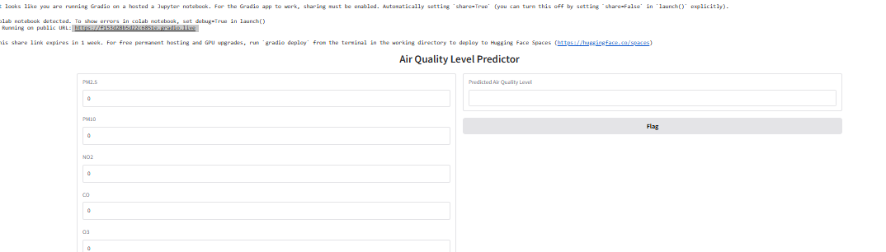0